**CHAPTER5**

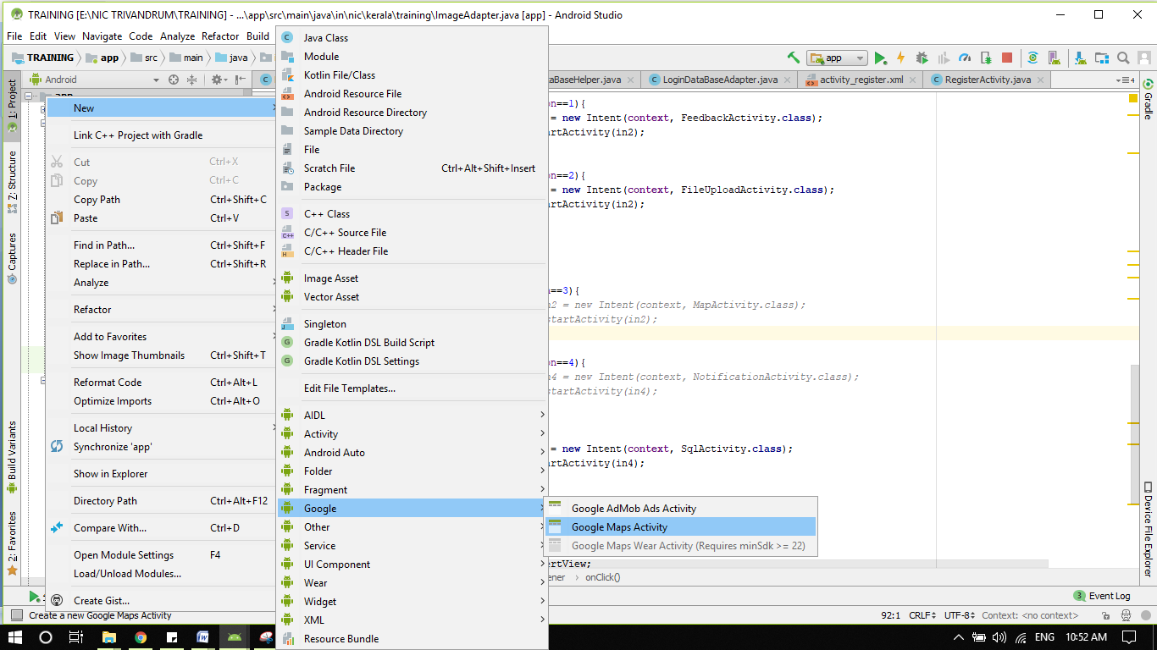

Create a Google Maps Activity as shown in the Figure and Name it **MapsActivity** .After creation of activity a new google_maps_api.xml file will be created where you need to paste the GoogleMaps API Key (which is not free for all users now)

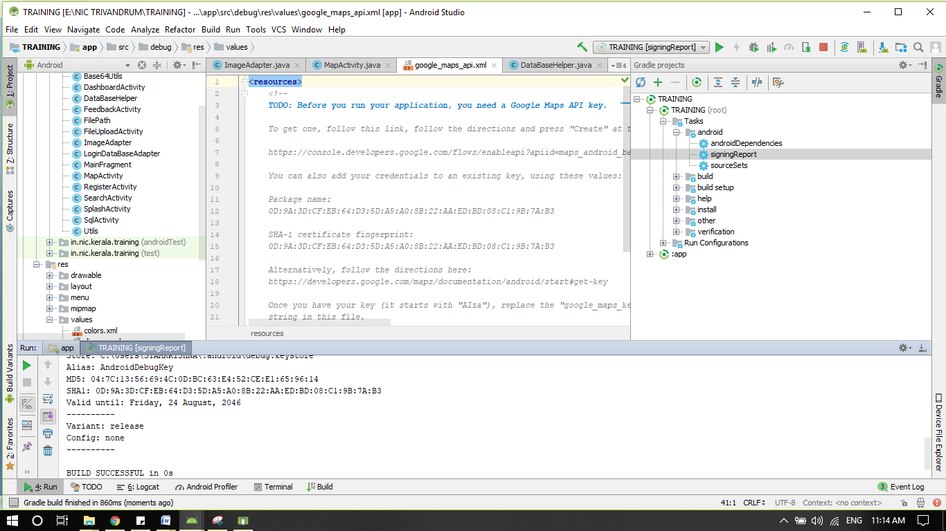

There will be a new API key configuration in androidmanifest.xml

<**meta-data  
 android:name="com.google.android.geo.API_KEY"  
 android:value="@string/google_maps_key"** />

**Get SHA1 for Android Studio**

SHA1 certificate fingerprint is required for Firebase features, Google API features like maps, google sign-in etc.

As of Android Studio 2.2, SHA-1 fingerprint can be obtained from inside the IDE itself. The most common way developers use to find the fingerprint is shooting up the console/terminal/cmd prompt and using the keytool command. Here’s an example for that:

keytool -list -v -keystore "/Users/bablu/trainingcertificate.jds" -alias key0 -storepass 1234567890 -keypass 1234567890

While debugging the application using emulator, android studio will be creating a debug certificate internally. But when you publish the apk for productin, you have to sign the apk with a production certificate.

keytool -list -v -keystore "C:\Users\SYAMKRISHNA\Desktop\ training.jks " -alias training -storepass 1234567890 -keypass 1234567890

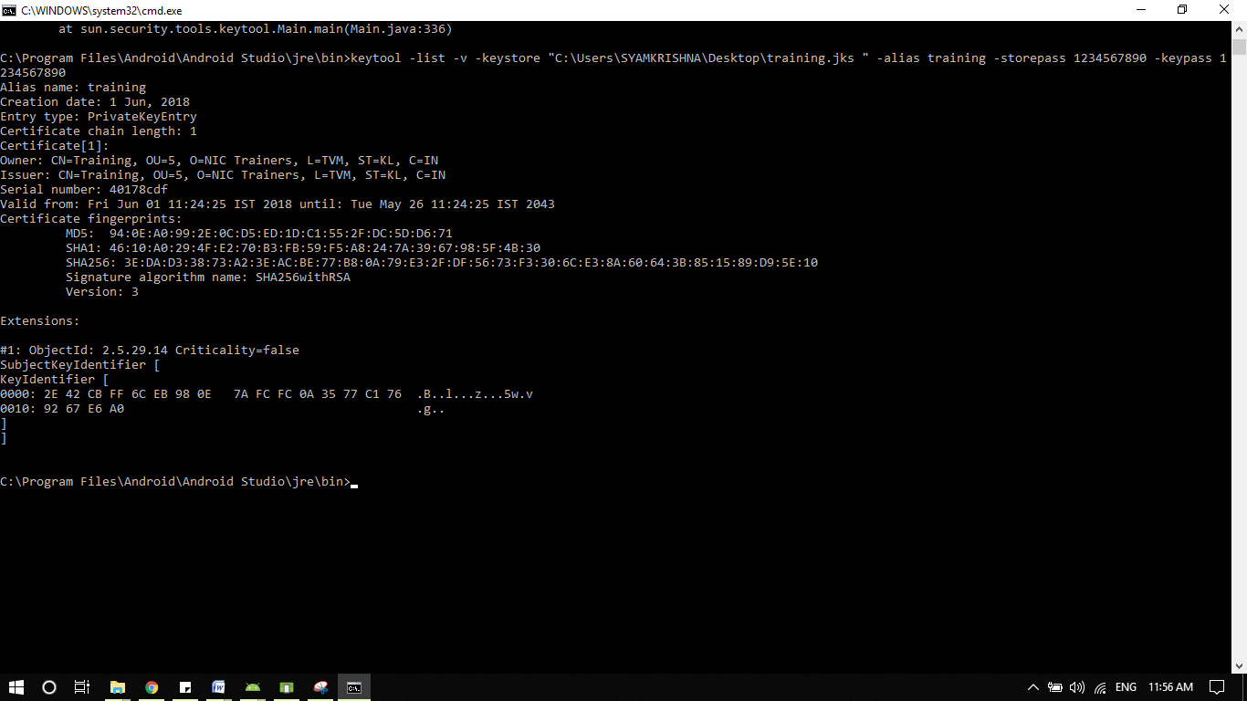

# Getting a google API

**Login to gmail and open the URL Given below**[**https://console.developers.google.com/flows/enableapi**](https://console.developers.google.com/flows/enableapi) **Create a project and proceed as shown in the images in the same order  
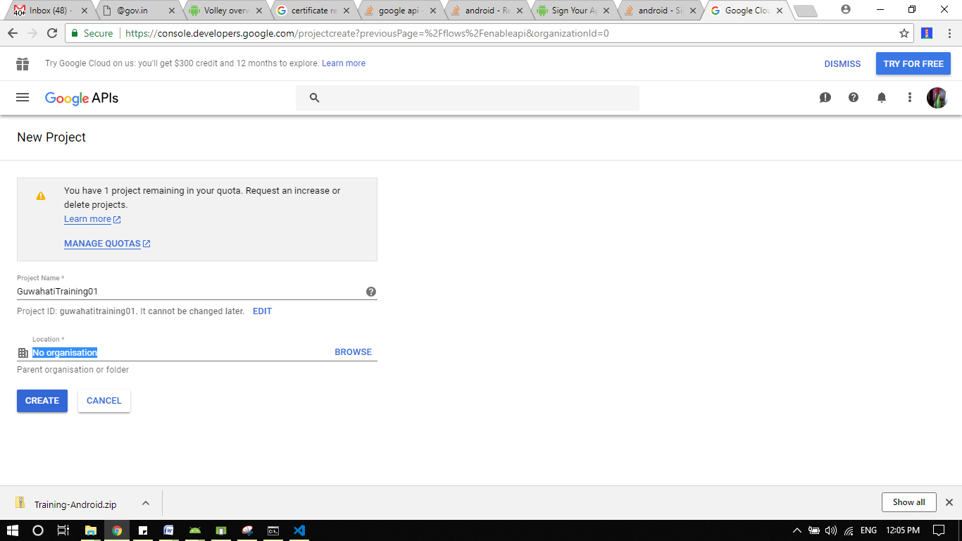**

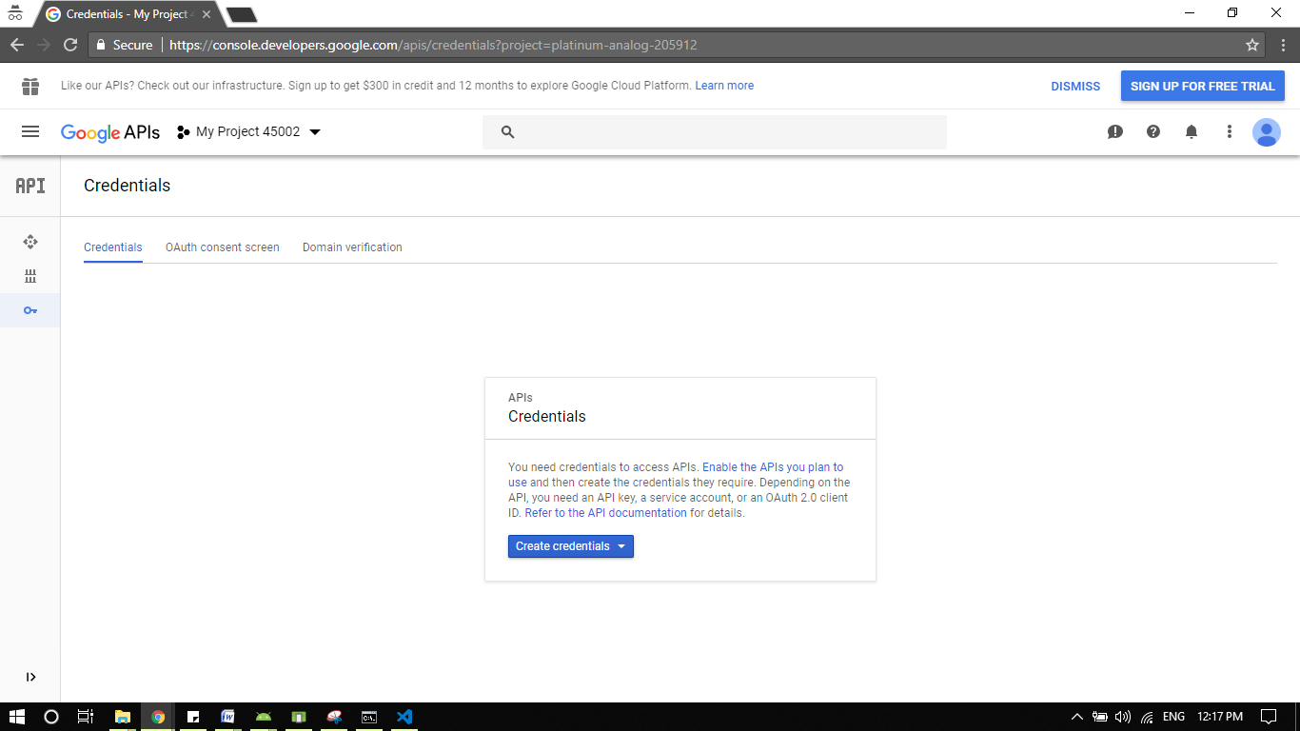

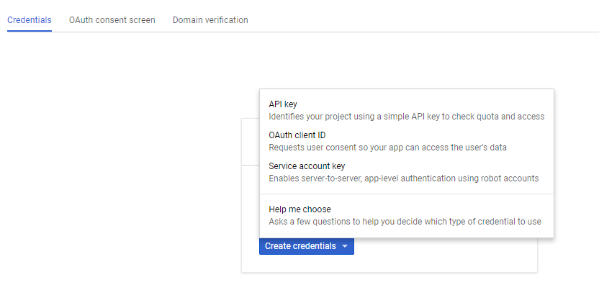

**Click on API Key to get a new API Key**

